

**Distinction Task 1**

## **Submission Process**

* Create a file named **DTASK1.PDF** where 9999 is the last 4 digits of your student ID. This is a PDF of the file named **DTASK1**.**DOCX** described below**.**
* This file will contain screen shots described in this document.
* Log into Doubtfire and submit this file into the appropriate **DTASK1** task in Doubtfire.
* Note: The screen shots required for this document will come from a Power BI file that you create. While you do not have to submit the Power BI file, **you must save and keep the Power BI file with all the visualisations that you have created.** Your tutor may request for you to submit a copy of the Power BI file for closer inspection.
* You must to complete **all** of the requirements 1-5 to achieve a satisfactory grade.
* You **need** to complete **all** of the requirements 1-7 to achieve an excellent grade.

## **Distinction Requirements For Submission**

* Download the file called MowTownN.accdb from Blackboard where N is the digit that matches the last digit of your student id.
* e.g. If your student id is 199185007, then download the file MowTown7.accdb
* (If your student ID ends with 'x', then download the file named MowTown9.accdb).
* If you have trouble connecting Power BI to the Access database, you may need to download data in each of the Access tables to a CSV file and then import each into Power BI.
* Use **PowerBI Desktop** to get the data from all tables in the Access database.
* Create the following visualizations:



* 1. A table visualization that displays the number of jobs allocated to each worker name



* 1. A Stacked column chart visualization that displays the total payments by month.



* 1. A clustered bar chart visualizatioCun that displays payments for   
     each service description
  2. Any visualization that you like that displays the top 5 suburbs by total payments.   
     Show suburb name and total payments.
* Place these four visualizations on a single report/screen. Also display your name and student id as a heading on the report in the **top left** corner (Your data values may differ).
* **Screen Capture** the visualizations (similar to the image below).
* Paste the screen capture in the appropriate position in the document named **DTASK1.DOCX**

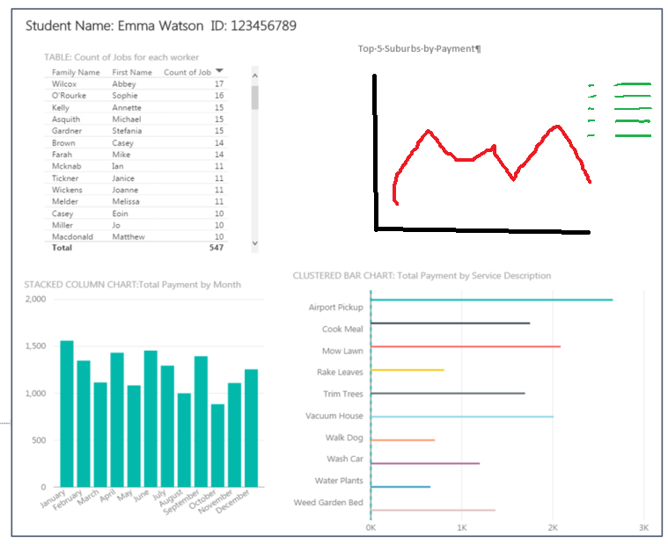

Top 5 Suburbs by Payment

* Create a **new column** in the **customer** table to combine customer id, surname and firstname.
* Create a **Matrix** visualisation that displays total jobs by Customer and Year.
* **Screen Capture** the Matrix visualization (similar to the image below – note the values may differ).
* Paste the screen capture in the appropriate position in the document named **DTASK1.DOCX**

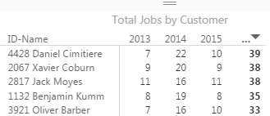

* Currently, the customer table contains a column named ContactType. Values are B,E,N,S.
* These codes have the following descriptions.

**ContactType Description**

E eMail only

B Both SMS and eMail

S SMS only

N None

* **Create a visualization** that displays the total number of customers that belongs to each of these contact descriptions. Add appropriate headings etc.
* **Screen capture** the visualization.
* Paste the screen captures in the appropriate position in the document named **DTASK1**.**DOCX**
* **Create any 3 additional visualizations** that you wish.
* The visualizations must show a degree of inventiveness (i.e. turning a previously used pie chart into a line chart or bar chart does not show any inventiveness at all).
* If necessary, you may create additional columns, tables, slicers, and/or functions.
* Ensure that each visualization has an appropriate heading that describes its purpose, named data axis, legend etc.
* **Screen Capture** each of the visualizations.
* Paste the screen captures in the appropriate position in the document named **DTASK1**.**DOCX**
* Take a screen capture of the Power BI **Relationship Manager** screen that displays all tables and the relationships between the tables.
* Paste the screen captures in the appropriate position in the document named **DTASK1**.**DOCX**
* Create a **new column** called **CustAge** in the customer table that calculates each customer's current age in years.
  + You may want to use the DateDiff() and Today() in your calculation.
  + A person born on 16/06/1989 would currently have an age of 27 (based on 1 April 2017)
* Create a **new column** called **CustAgeGroup**. This requires a formula based on CustAge. The formula will do the following:
* Assign the value 0 for any person who is between 0 and 9 years old
* Assign the value 1 for any person who is between 10 and 19 years old
* Assign the value 2 for any person who is between 20 and 29 years old
* …
* Assign the value 9 for any person who is between 90 and 99 years old
* *Note: You may assume that no-one is over 99 years old in the data provided)*
* *Example: If the Age is 47 then the CustAgeGroup value for this record in 4.*
* Select the Enter Data in the Data window of Power BI

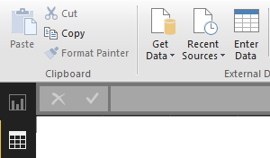

* Create a table named **AgeGroups9999** (where 9999 is the last 4 digits of your student ID).
* The table must have two columns named AgeCode and

AgeDescription.

* The example data must be entered into the table.

|  |  |
| --- | --- |
| AgeCode | AgeDescription |
| 0 | Age 0-9 |
| 1 | Age 10-19 |
| 2 | Age 20-29 |
| 3 | Age 30-39 |
| 4 | Age 40-49 |
| 5 | Age 50-59 |
| 6 | Age 60-69 |
| 7 | Age 70-79 |
| 8 | Age 80-89 |
| 9 | Age 90-99 |

* The table must be added into the **relationships** with a M:1 relationship between CustAgeGroup and AgeCode.
* Finally, create a **Donut Chart** visualization that displays the number of customers in each Age Group.
* Add headings and appropriate legend to the visualization.
* **Screen Capture** the **AgeGroups9999** table and all the rows in it.
* **Screen Capture** the **Donut Chart** visualization.
* Paste the screen captures in the appropriate position in the document named **DTASK1.DOCX**
* Add an **additional column** to the **customer** table in Power BI.
* This column must be a single string the combines the suburb name, postcode   
  and the text "Victoria, Australia".
* Use this additional column in the creation of a **map visualization** that displays **total jobs** by **customer location** (see example below)



* **Screen Capture** the Map visualization that shows the 10-20 suburbs where the suburb with the **largest** total jobs value is roughly centred in the map.
* Paste the screen capture in the appropriate position in the document named **DTASK1.DOCX**

